

VIRTUAL INTERIOR DESIGN

Project



|  |  |
| --- | --- |
| **Submitted To:** | **Kinza Sardar** |
| **Submitted By:** | **Taimoor Ahmad** |
| **ID:** | **F2023065310** |
| **Section:** | **W6** |

## UNIVERSITY OF MANAGEMENT AND TECHNOLOGY, LAHORE, PAKISTAN

# PROBLEM STATEMENT

The project of virtual interior design in software engineering aims to address the need for a more efficient, accurate, and interactive approach to designing interior spaces. Traditional interior design processes often involve cumbersome methods like hand-drawn sketches, physical models, and multiple revisions, leading to inefficiencies, miscommunications, and delays.

The problem this project seeks to solve is the lack of effective tools for visualizing and communicating design concepts, resulting in difficulties for both designers and clients in understanding and finalizing designs. Without virtual interior design software, there's often a disconnect between the initial design vision and the final outcome, leading to dissatisfaction, costly revisions, and wasted resources.

By developing virtual interior design software, the project aims to provide a solution that enables designers and clients to collaborate more effectively, visualize designs in 3D, experiment with different options, and make informed decisions before any physical implementation occurs. This approach streamlines the design process, reduces errors, enhances communication, and ultimately leads to more successful interior design projects.

# PURPOSE

#### Efficiency:

Streamline the design process by reducing the time and effort required to create and revise interior designs.

#### Accuracy:

Improve the precision of design concepts through detailed and realistic 3D visualizations.

#### Communication:

Enhance communication between designers and clients, ensuring a clear understanding of design ideas and expectations.

#### Collaboration:

Enable easy collaboration, allowing designers and clients to work together in real-time on design projects.

#### Decision-Making:

Provide tools for experimenting with different design options, helping clients make informed decisions before physical implementation.

#### Cost-Effectiveness:

Reduce costly revisions and resource waste by identifying and addressing design issues early in the process.

#### Satisfaction:

Increase client satisfaction by aligning the final outcome more closely with the initial design vision.

# SCOPE OF THE PROJECT

The scope of the virtual interior design project in software engineering includes developing a comprehensive digital platform that:

#### User Interface:

Creates a user-friendly interface for designers and clients.

#### 3D Visualization:

Integrates advanced 3D modeling and rendering capabilities.

#### Collaboration Tools:

Provides real-time collaboration features for designers and clients.

#### Design Library:

Includes a library of furniture, fixtures, and materials for easy selection.

#### Customization:

Allows customization of design elements to match client preferences.

#### Cost Estimation:

Offers tools for budget estimation and cost tracking.

#### Feedback System:

Facilitates feedback and revisions through interactive tools.

#### Export Options:

Enables exporting of final designs in various formats for implementation.

4

# DEFINITIONS

**3D Visualization**: The process of creating three-dimensional images or animations to represent design concepts realistically.

**UI (User Interface)**: The space where interactions between humans and machines occur, particularly the design and layout of software interfaces.

**API (Application Programming Interface)**: A set of protocols and tools for building software and applications, enabling different software entities to communicate with each other.

**Customization**: The ability to modify design elements to meet specific user preferences or requirements.

**Feedback System**: A feature that allows users to give and receive feedback on designs, often including comments, ratings, and suggested revisions.

**Export Options**: The ability to save and output designs in various formats, such as images, PDFs, or CAD files for sharing and implementation.

**VR (Virtual Reality)**: A simulated experience that can be similar to or completely different from the real world, often used for immersive design visualization.

**AR (Augmented Reality)**: An interactive experience where digital elements are overlaid onto the real world, enhancing the design visualization process.

5

# OVERVIEW

The virtual interior design project in software engineering aims to create an advanced digital platform that revolutionizes the interior design process. This platform will provide a userfriendly interface for both designers and clients, allowing them to collaborate seamlessly in real-time. Key features will include 3D visualization, a comprehensive design library, customization options, cost estimation tools, and a robust feedback system.

The platform will leverage cutting-edge technologies such as CAD, VR, and AR to deliver precise and immersive design experiences. By integrating these tools, the project will streamline the design workflow, enhance communication, and reduce costly revisions. The end goal is to ensure that the final design aligns closely with the client's vision, leading to higher satisfaction and more successful interior design projects.

8

# PROCESS MODEL

We use The Agile model because it suits the virtual interior design project due to following reasons:

#### Flexibility:

Agile allows for iterative development, which is ideal for incorporating ongoing client feedback and adapting to changing design requirements.

#### Collaboration:

Agile emphasizes collaboration between developers, designers, and clients, which aligns with the need for seamless communication and real-time collaboration in the project.

#### Incremental Delivery:

The project can be broken down into smaller, manageable parts, delivering features incrementally. This ensures that clients can start using and providing feedback on core features early in the development process.

#### Customer Involvement:

Agile involves customers throughout the development process, ensuring that the final product meets their expectations and needs.

#### Continuous Improvement:

Agile promotes continuous improvement through regular retrospectives, helping the team refine processes and deliver better results over time.

By using the Agile model, the virtual interior design project can efficiently handle evolving requirements, ensure high client satisfaction, and deliver a high-quality, user-friendly platform.

7

**Software Requirement Specification (SRS)**

### Overall Description

i.

#### Product Functions:

* **3D Visualization:** The software provides detailed 3D visualizations of interior designs, including furniture placement, color schemes, and lighting.
* **Collaboration Tools:** Real-time collaboration features that allow designers and clients to work together on design projects.
* **Customization:** Ability to customize design elements such as layouts, colors, and materials to meet user preferences.
* **Cost Estimation:** Tools for estimating project costs based on design choices and materials.
* **Feedback System:** A feedback system for clients to provide input and revisions on design concepts.

ii.

#### User Characteristics:

* **Designers:** Experienced interior designers who use the software to create and visualize designs for clients.
* **Clients/Homeowners:** Individuals or businesses seeking to design or remodel their interior spaces, who collaborate with designers using the software.
* **Technical Users:** IT professionals or support personnel who manage the software's installation, updates, and technical support.

iii.

#### General Constraints:

* **Hardware Requirements:** The software may have specific hardware requirements, such as graphics capabilities for rendering 3D designs.
* **Software Compatibility:** Compatibility with different operating systems and software versions, ensuring accessibility for a wide range of users.
* **Data Security:** Implementation of robust security measures to protect user data, designs, and intellectual property.
* **Scalability:** Ability to handle a growing number of users and projects without compromising performance.

10

**User Training:** Providing user training and support resources to ensure smooth adoption and usage of the software.

1. **Functional Requirement Table:**

|  |  |
| --- | --- |
| **User Registration/Login** | Users can create accounts or log in to access the interior design platform. |
| **Profile Management** | Users can edit their profiles, including personal information and design preferences. |
| **Room Creation** | Users can create virtual rooms specifying dimensions and layout. |
| **Furniture Catalog** | A catalog of virtual furniture items from different styles and brands. |
| **Furniture Placement** | Users can select furniture items from the catalog and place them within the virtual room. |
| **Customization Options** | Users can customize furniture items, such as color, material, and size. |
| **Design Collaboration** | Users can invite others to collaborate on a design project and share feedback. |
| **3D Visualization** | Realistic 3D rendering of designed rooms to provide a visual representation. |
| **Virtual Reality (VR) Mode** | Users can view and interact with their designed rooms in virtual reality for immersive experiences. |
| **Cost Estimation** | Estimate the cost of selected furniture items and overall design project. |
| **Shopping Integration** | Integration with online stores for direct purchase of furniture items within the platform. |

|  |  |
| --- | --- |
| **Design Inspiration** | Provide design inspiration through curated collections, articles, or user-generated content. |

1. **Non Functional Requirement Table:**

|  |  |
| --- | --- |
| **Non-Functional Requirement** | **Description** |
| **Performance** | The system must respond to user interactions within 2 seconds to ensure a smooth and responsive user experience. |
| **Scalability** | The system should be able to handle an increasing number of users and designs without a significant decrease in performance. |
| **Reliability** | The system should have a high level of reliability, ensuring minimal downtime and data loss. |
| **Security** | User data must be securely stored and transmitted using encryption protocols to prevent unauthorized access. |
| **Usability** | The user interface should be intuitive and easy to navigate, requiring minimal training for users to operate effectively. |
| **Compatibility** | The system should be compatible with a range of devices and browsers to accommodate various user preferences. |
| **Accessibility** | The platform should be accessible to users with disabilities, following accessibility standards such as WCAG. |
| **Maintainability** | The system should be designed with modular components and wellcommented code to facilitate future maintenance and updates. |

**PROJECT MANAGEMENT**

## Work Breakdown Structure (WBS)

**Major Tasks:**

### Research and Planning:

Research user needs, market trends, and technology requirements.

### Design Phase:

#### User Interface (UI) Design:

Create mockups and wireframes for the software interface. **ii. 3D Visualization Tools:**

Develop the 3D modeling and rendering capabilities.

### Development Phase:

#### Backend Development:

Set up databases, servers, and APIs.

#### Frontend Development:

Build the actual software interface using the designs from the design phase.

### Collaboration Features:

Implement features for real-time collaboration between designers and clients.

### Customization Options:

Develop tools for customizing design elements.

### Cost Estimation Tools:

Create features for budget estimation.

### Feedback System:

Build a system for collecting and managing user feedback.

### Testing Phase:

#### Unit Testing:

Test individual components for errors. **ii.**

#### Integration Testing:

Ensure all parts work together seamlessly. **iii.**

#### User Testing:

Get feedback from real users to identify any issues.

### Deployment and Maintenance:

**Deployment:**

Launch the software for users.

### Maintenance:

Provide ongoing support and updates.

# COST ESTIMATIONS:

### Software Costs:

Licenses for any third-party software or development tools needed for creating 3D visualizations and collaboration features.

### Hardware Costs:

High-performance computers for rendering 3D models and possibly VR/AR equipment.

### Labor Costs:

Salaries for the development team, designers, and testers.

### Miscellaneous Costs:

Expenses such as office supplies, internet, marketing, and user training materials.

# RISK TABLE:

|  |  |  |  |  |
| --- | --- | --- | --- | --- |
| Risk | Description | i | Likelihood  t | Mitigation |
| Limited User | Users may not embrace | High | Medium | Conduct market research to understand user needs and preferences.  Continuously gather feedback for improvements. |
| Adoption | the virtual interior design |  |  |
|  | platform, resulting in low |  |  |
|  | usage and engagement. |  |  |
| Technical Compatibility Issues | Compatibility issues with different devices, browsers, or operating systems may hinder user experience. | High | Medium | Test the platform across various devices and browsers during development. Implement responsive design principles. |
| Data Security Breach | Unauthorized access to user data could result in privacy violations and damage to the platform's reputation. | High | Low | Implement robust security measures, including encryption, user authentication, and regular security audits. |
| Performance Degradation | Slow response times or system crashes could lead to user frustration and abandonment of the platform. | High | Medium | Conduct performance testing to identify and address bottlenecks. Optimize code and infrastructure as needed. |

|  |  |  |  |  |
| --- | --- | --- | --- | --- |
| Design Inaccuracy | Design inaccuracies or discrepancies between virtual and real-world settings may lead to user dissatisfaction. | High | Medium | Implement accurate measurement tools and realistic rendering techniques. Allow users to preview designs in realworld settings. |
| Vendor or Supplier Issues | Delays or quality issues from furniture vendors or suppliers could disrupt project timelines and deliverables. | High | Medium | Establish partnerships with reliable vendors. Have backup suppliers in place and maintain open communication channels. |
| Lack of Design Expertise | Users may struggle to create aesthetically pleasing designs without professional interior design knowledge. | Medium | High | Provide design templates, tutorials, and access to expert advice or consultations within the platform. |
| Regulatory Compliance | Failure to comply with legal regulations, such as data protection laws or industry standards, could result in penalties or fines. | High | Low | Stay informed about relevant regulations and ensure platform features and policies are compliant. |
| Financial | Budget limitations may | High | Medium | Conduct thorough costbenefit analysis. Prioritize essential features and seek funding or investment opportunities. |
| Constraints | restrict the development |  |  |
|  | and maintenance of the |  |  |
|  | platform, affecting its |  |  |
|  | quality and scalability. |  |  |

* + **RESOURCE ALLOCATION:**

### Team Members:

**Project Manager:**

Oversees the project, ensures deadlines are met.

### UI/UX Designers:

Design the user interface and user experience.

### Developers:

Code the software, implement 3D visualization and collaboration features.

### Testers:

Test the software for bugs and usability issues.

### Tools:

**Development Tools:**

IDEs, graphic design software, 3D modeling tools.

### Collaboration Tools:

Software like Slack or Microsoft Teams for communication. **iii.**

### Time:

Allocate time for each phase (planning, design, development, testing, deployment. **iv.**

### Assigning Tasks:

Ensure each team member knows their specific tasks and deadlines.

# TIMELINE OF DELIVERABLES:

**i. Planning Phase:** 2 weeks

### Research and Planning:

Conduct initial research and plan the project. **ii. Design Phase:** 4 weeks

**UI Design:** Create wireframes and mockups.

**3D Visualization Tools Design:** Plan the 3D features.

1. **Development Phase:** 8 weeks **Backend Development:** 2 weeks **Frontend Development:** 3 weeks **Collaboration Features:** 1 week **Customization Options:** 1 week **Cost Estimation Tools:** 1 week **Feedback System:** 1 week **iv.**

**Testing Phase:** 4 weeks **Unit Testing:** 1 week **Integration Testing:** 1 week **User Testing:** 2 weeks

### v. Deployment and Maintenance: 2 weeks

**Deployment:** 1 week

**Maintenance:** Ongoing

**Design Engineering**

**COMPENENT LEVEL DESIGN**

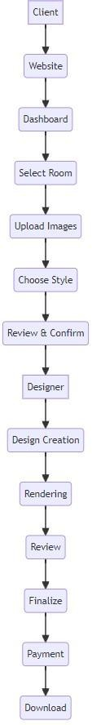



**ARCHITECTURAL DESIGN**

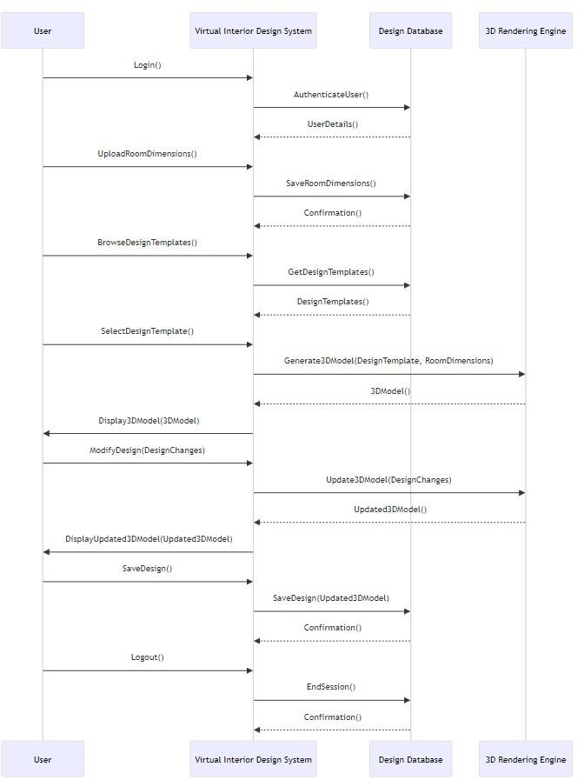**SEQUENCE DIAGRAM**

**ACTIVITY DIAGRAM**

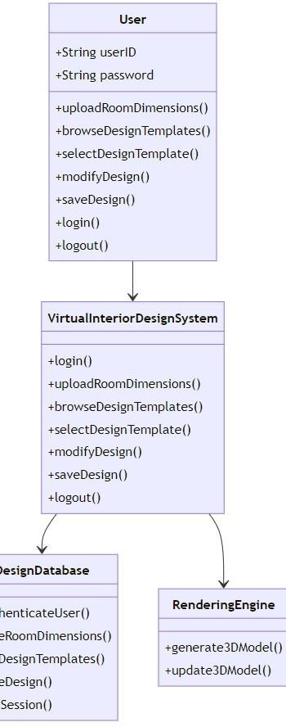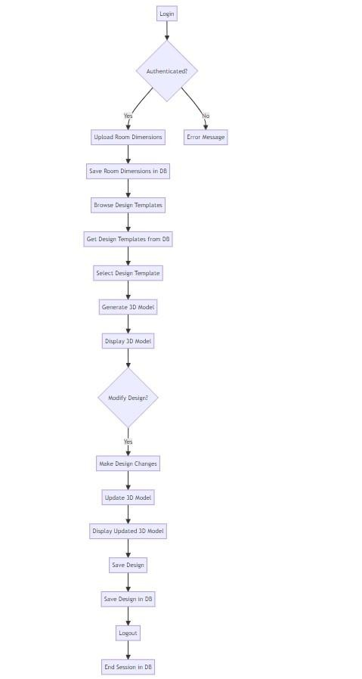

**ERD DIAGRAM**

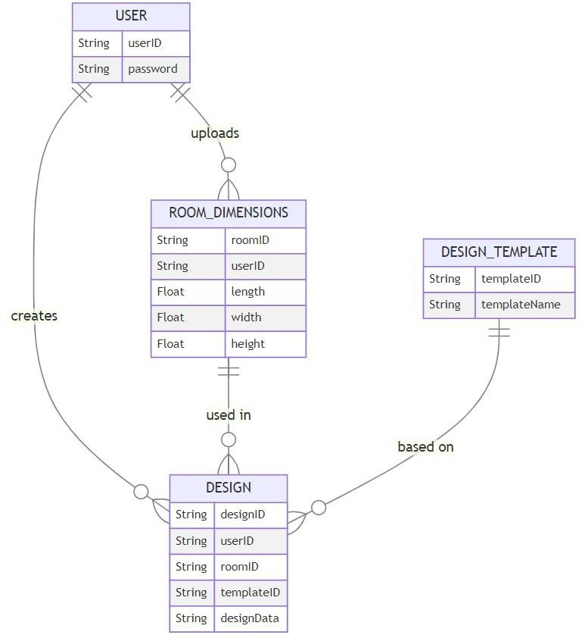

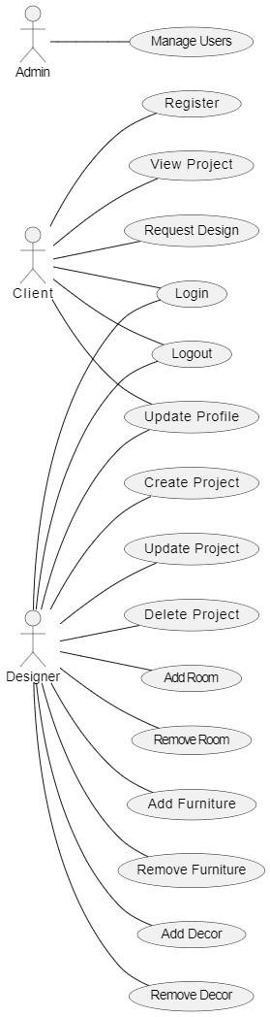**Use Case Diagram**

**Testing:**

**Testing Strategies & Plans:**

### Test-Driven Development (TDD):

* Begin with TDD to ensure that each feature is accompanied by automated tests. In virtual interior design, this could mean writing tests to validate elements like room layout, furniture placement, color schemes, etc.
* Write tests before implementing features. This helps clarify requirements and ensures test coverage from the outset.

### Continuous Integration (CI):

* Set up a CI pipeline to automatically build, test, and deploy changes. This ensures that new code doesn't break existing functionality and maintains the overall stability of the project.
* Integrate automated tests into the CI process to run whenever changes are pushed to the repository. This provides rapid feedback on the quality of the code.

### Exploratory Testing:

* Given the creative nature of interior design, incorporate exploratory testing to discover unforeseen issues and provide qualitative feedback.
* Allow testers to freely explore the virtual environment, trying different design options, configurations, and interactions to uncover usability issues and design flaws.

### User Acceptance Testing (UAT):

* Involve stakeholders, including designers and clients, in UAT to ensure that the virtual interior design meets their expectations and requirements.
* Encourage feedback throughout the development process to incorporate changes early and avoid costly rework later.

### Pair Testing:

* Implement pair testing where developers and testers collaborate closely to identify and address issues together.
* This fosters communication, knowledge sharing, and a shared understanding of the project's goals and requirements.

### Regression Testing:

* Maintain a comprehensive suite of regression tests to ensure that new changes don't introduce regressions or unintended side effects.
* Automate regression tests wherever possible to streamline the testing process and catch regressions early.

### Agile Testing Quadrants:

* Use the Agile Testing Quadrants model to categorize and prioritize testing efforts.
* **Quadrant 1** (Technology-facing tests): Unit tests, component tests.
* **Quadrant 2** (Business-facing tests): Acceptance tests, exploratory testing.
* **Quadrant 3** (Business-facing but supporting technology): Performance testing, security testing.
* **Quadrant 4** (Technology-facing but supporting business): Load testing, stress testing.

### Adaptability:

* Remain flexible and adaptable to changing requirements and priorities, as Agile projects often involve evolving customer needs and market conditions.
* Continuously review and refine the testing strategy based on feedback and lessons learned throughout the project lifecycle.

By incorporating these testing strategies and plans into this Agile virtual interior design project, we can ensure a high-quality product that meets both technical and user requirements while embracing the iterative and collaborative nature of Agile development.

**Test Cases:**

TEST CASE 1

|  |  |  |  |  |  |  |
| --- | --- | --- | --- | --- | --- | --- |
| SN  . | Actions | Input | Expecte d Output | Actual Output | Test Browser | Test Result s |
| 1. | Login to | Username, | Success- | Actual | Chrome | pass |
|  | the virtual | password | Full login | login |  |  |
|  | interior |  |  | status |  |  |
|  | design |  |  |  |  |  |
|  | platform |  |  |  |  |  |
| 2. | Create a new design project | Project name, description client information | Project success fully created | New project "Living Room Redesign  " created | Firefox | pass |
|  |  |  |  | successfu |  |  |
|  |  |  |  | ll |  |  |
| 3. | Add a new room to the design | Room type, dimensions, layout preferences | Room added to the design | Bedroom added with specified dimension | Safari | pass |
|  |  |  |  | s and style |  |  |

TEST CASE 2

|  |  |  |  |  |  |  |
| --- | --- | --- | --- | --- | --- | --- |
| SN. | Actions | Input | Expected Output | Actual output | Test Browser | Test Results |
| 1 | Place | Furniture | Furniture | Sofa placed at coordin ates (50,  100) | Firefox | pass |
|  | furniture in | Selection: | placed in |  |  |
|  | the room | Sofa, | the room |  |  |
|  |  | Placement |  |  |  |
|  |  | Coordinate |  |  |  |
|  |  | s: (x=50, |  |  |  |
|  |  | y=100) |  |  |  |
| 2 | Change  room color | Selected Color | Room  color | Room  color | Safari | pass |
|  | scheme | Palette:  Blue, White, Gray | scheme updated | scheme change d to Blue,  White, |  |  |
|  |  |  |  | Gray |  |  |
| 3 | Save the | Save button | Design | Design project saved succes sfully | Chrome | pass |
|  | design | clicked | project |  |  |
|  | project |  | saved |  |  |
|  |  |  | success |  |  |
|  |  |  | fully |  |  |

TEST CASE 3

|  |  |  |  |  |  |  |
| --- | --- | --- | --- | --- | --- | --- |
| SN | Actions | Input | Expected output | Actual output | Test Browers | Test Resu lts |
| 1 | Share the design with the client | Share button clicked, Client Email: client@ example. com | Design project shared with the client | Link shared with client@ex ample.co m | Firefox | Pass |
| 2 | Review design with the client | Open shared link,  View | Client approves the design | Client provides positive  feedback | Chrome | Pass |
|  |  | design |  | on the |  |  |
|  |  |  |  | design |  |  |
| 3 | Finalize design and mark as complete | Mark as complete button clicked | Design project marked as complete | Design project marked as complete | Safari | Pass |

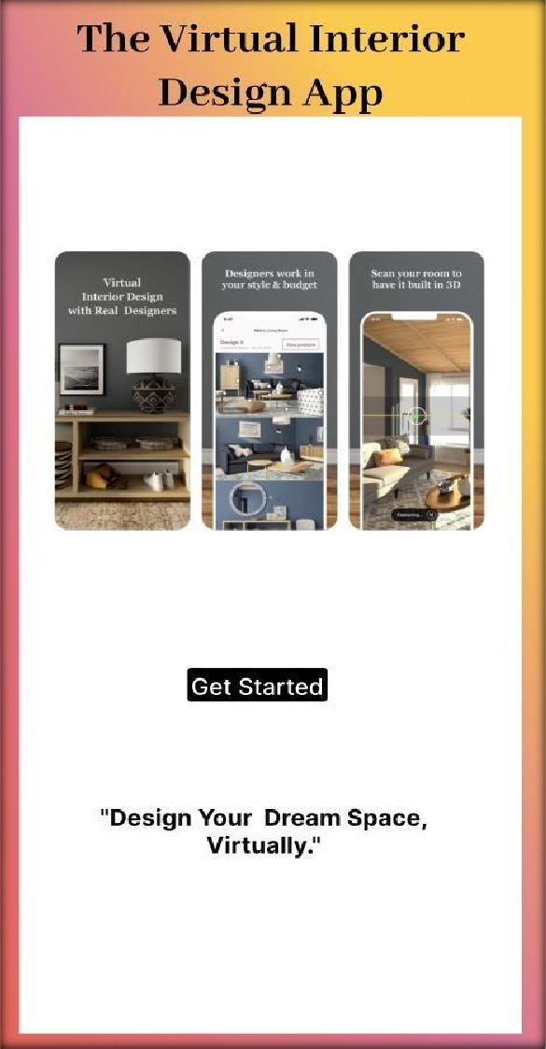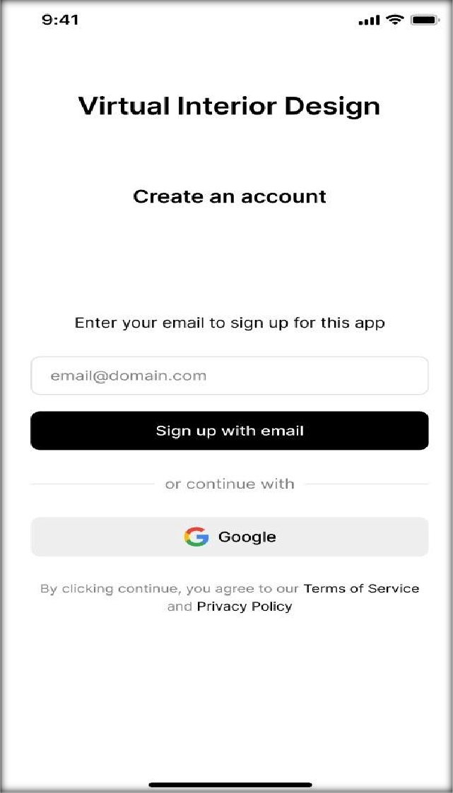

**Prototypes:**

**Front-end Layout:**

